**CHANDIGARH UNIVERSITY**

**Gharuan, Mohali**

Institute/Department: UNIVERSITY INSTITUTE OF ENGINEERING

Division: BLOCK 14

Subject Name: SOFTWARE ENGINEERING

Subject Code: CST-216

----------------------------

UID(s): 18BCS6024, 18BCS6053, 18BCS6093

Name(s):MOHIT BASLIYAL, SATYAM VIBHU, PRATIBHA

Section: AIT ALIML-1

Group Name: U

**Project No.: 1**

**Max. Marks: 10**

**Date of Allotment: 9 September 2019**

**Last date of Submission: 23 September 2019**

---------------------------------------------------------------------------------------------------------------------------

Start from NEXT Page Only !

**Software Requirements Specification**

**for**

**GOOGLE LENS**

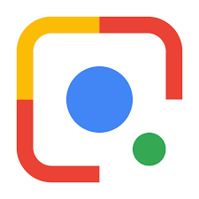

**Version 1.0 approved**

**Prepared by**

**MOHIT BASLIYAL**

**SATYAM VIBHU**

**PRATIBHA LADHA**

**AIT AIML-1**

**SEPTEMBER 19,2019**

**Table of Contents PAGE NO.**

**Table of Contents 3**

**Revision History 3**

**1. Introduction 4**

1.1 Purpose 4

1.2 Document Conventions 4

1.3 Intended Audience and Reading Suggestions 4

1.4 Project Scope 4

1.5 References 4

**2. Overall Description 5**

2.1 Product Perspective 5

2.2 Product Features 5

2.3 User Classes and Characteristics 6

2.4 Operating Environment 6

2.5 Design and Implementation Constraints 6,7

2.6 User Documentation 7

2.7 Assumptions and Dependencies 8

**3. System Features 8**

3.1 System Feature 1 8

3.2 System Feature 2 (and so on) 9

**4. External Interface Requirements 9**

4.1 User Interfaces 9

4.2 Hardware Interfaces 10

4.3 Software Interfaces 10

4.4 Communications Interfaces 10,11

**5. Other Nonfunctional Requirements**  **11**

5.1 Performance Requirements 11

5.2 Safety Requirements 11

5.3 Security Requirements 12

5.4 Software Quality Attributes 12,13,14

**6. Other Requirements 15**

**Appendix A: Glossary 15**

1. **Introduction**
   1. **Purpose**

It allows users to do things like pointing their smartphone’s camera at anything, for example, a particular flower, and ask Google Assistance that what is the object they are pointing at and they will not only get the answer of what it is but also will get suggestions to act on the object or even nearby florists and flower shops in case of a flower. It will do the same for shoes, dresses, and many other things you will point at.

* 1. **Document Conventions**

This document follows MLA Format. Bold-faced text has been used to emphasize section and sub-section headings. Highlighting is to point out words in the glossary and italicized text is used to label and recognize diagrams.

* 1. **Intended Audience and Reading Suggestions**

This document is to be read by the development team, the project managers, marketing staff, testers and documentation writers. Our stakeholders, company manufacturing associated Software Requirements Specification for hardware, company providing embedded operating system, shareholders and distributors who markets the finished product, may review the document to learn about the project and to understand the requirements. The SRS has been organized approximately in order of increasing specificity. The developers and project managers need to become intimately familiar with the SRS. Others involved need to review the document as such: Overall Description – Marketing staff have to become accustomed to the various product features in order to effectively advertise the product. System features – Testers need an understanding of the system features to develop meaningful test cases and give useful feedback to the developers. External Interface Requirements – The hardware developers need to know the requirements of the device they need to build. The marketing staff also needs to understand the external interface requirements to sell the product by describing the user-friendly features of the Google Lens.

* 1. **Project Scope**

The Google Lens has features that enable any users to do things like pointing their smartphone’s camera at anything, for example, a particular flower, and ask Google Assistance that what is the object they are pointing at and they will not only get the answer of what it is but also will get suggestions to act on the object or even nearby florists and flower shops in case of a flower.

* 1. **References**
     1. **www.google.com**

1. **Overall Description**
   1. **Product Perspective**

**Google Lens** is an [image recognition](https://en.wikipedia.org/wiki/Image_recognition) technology developed by [Google](https://en.wikipedia.org/wiki/Google), designed to bring up relevant information related to objects it identifies using visual analysis based on a neural network.First announced during [Google I/O](https://en.wikipedia.org/wiki/Google_I/O) 2017, it was first provided as a standalone app, later being integrated into Android's standard camera app.

* 1. **Product Features**

When directing the phone's camera at an object, Google Lens will attempt to identify the object or read barcodes, QR codes, labels and text, and show relevant search results and information. For example, when pointing the device's camera at a [Wi-Fi](https://en.wikipedia.org/wiki/Wi-Fi) label containing the network name and password, it will automatically connect to the [Wi-Fi](https://en.wikipedia.org/wiki/Wi-Fi) source that has been scanned. Lens is also integrated with the [Google Photos](https://en.wikipedia.org/wiki/Google_Photos) and [Google Assistant](https://en.wikipedia.org/wiki/Google_Assistant) apps. The service is similar to [Google Goggles](https://en.wikipedia.org/wiki/Google_Goggles), a previous app that functioned similarly but with less capability. Lens uses more advanced [deep learning](https://en.wikipedia.org/wiki/Deep_learning) routines in order to empower detection capabilities, similar to other apps like [Bixby Vision](https://en.wikipedia.org/wiki/Bixby_Vision) (for [Samsung](https://en.wikipedia.org/wiki/Samsung) devices released after 2016) and *Image Analysis Toolset* (available on [Google Play](https://en.wikipedia.org/wiki/Google_Play)); During [Google I/O](https://en.wikipedia.org/wiki/Google_I/O) 2019, Google announced four new features. The software will be able to recognize and recommend items on a menu. It will have the ability to also calculate tips and split bills, show how to prepare dishes from a recipe and can use [text-to-speech](https://en.wikipedia.org/wiki/Speech_synthesis).

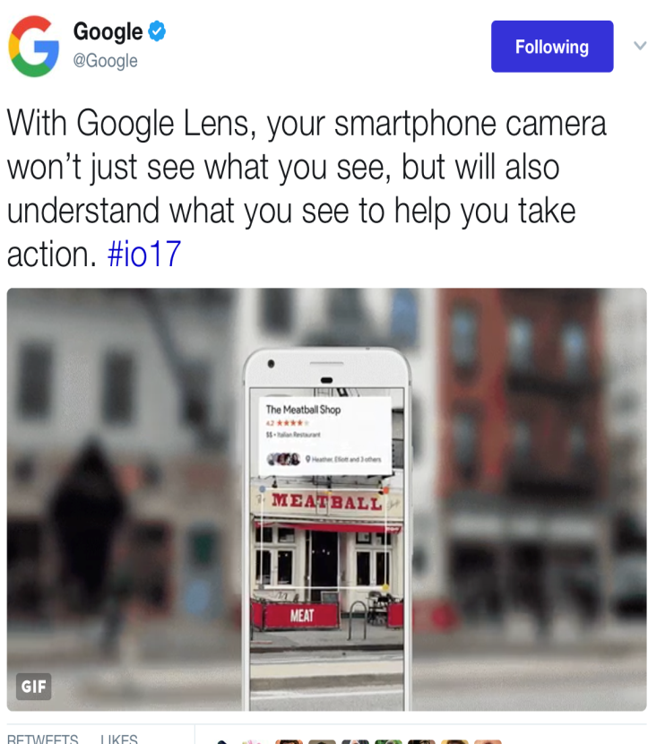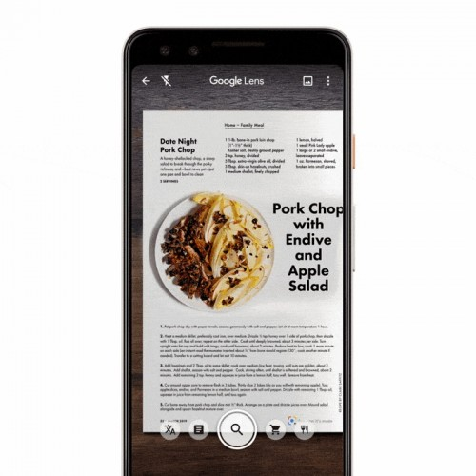

* 1. **User Classes and Characteristics**
* Google Lens is a super-powered version of Google Googles, and it's quite similar to Samsung's Bixby Vision. It enables you to do things such as point your phone at something, such as a specific flower, and then ask Google Assistant what the object you're pointing at is. You'll not only be told the answer, but you'll get suggestions based on the object, like nearby florists, in the case of a flower.
* Other examples of what Google Lens can do include being able to take a picture of the SSID sticker on the back of a Wi-Fi router, after which your phone will automatically connect to the Wi-Fi network without you needing to do anything else. Yep, no more crawling under the cupboard in order to read out the password whilst typing it in your phone. Now, with Google Lens, you can literally point and shoot.
  1. **Operating Environment**

[Google Lens](https://support.google.com/photos/answer/7539151?co=GENIE.Platform%3DAndroid&hl=en) lets you connect to the world through your phone in a new way. Google Lens integrates with Google Assistant and lets you look up objects and places through your camera. Please note that Google Lens will work on any device with the latest version of Google Photos. Currently, Google Lens can only be used if your device language is set to English.

* 1. **Design and Implementation Constraints**
* [Google Lens](https://www.digitaltrends.com/mobile/google-lens-news/), first introduced at Google I/O 2017, is one of the most exciting Android features for years. Originally an exclusive feature only found on Pixel smartphones, Google Lens is now baked into many [Android handsets](https://www.digitaltrends.com/mobile/best-android-phones/), and is available as an app in the Play Store.
* Google Lens combines the power of A.I. with deep machine learning to provide users with information about many things they interact with in daily life. Instead of simply identifying what an object is, Google Lens can understand the context of the subject. So if you take a picture of a flower, Google Lens will not just identify the flower, but provide you with other helpful information, like where there are florists in your area. It also does useful things like scanning QR codes, copying written text, and even live translation of other languages.

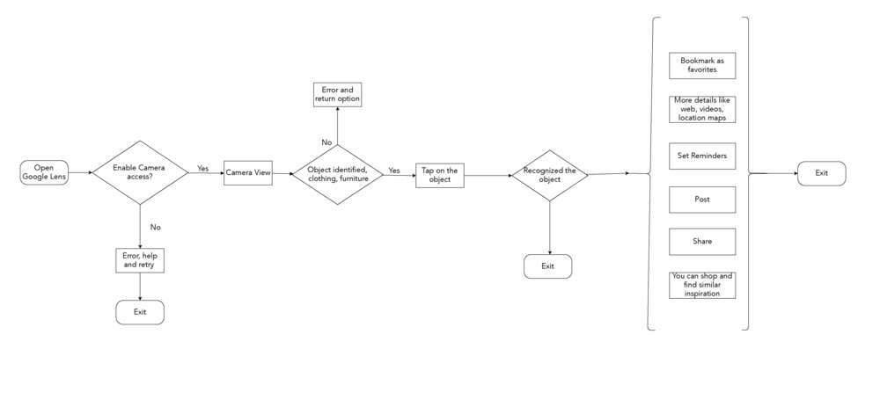

* 1. **User Documentation**

Tap the Lens icon while viewing a photo. Once you've done so, you'll notice that dots are displayed on the screen as your phone analyzes the objects in the photo. Google Assistant will then pop up and give you some information about the objects in the image. You can then use Assistant to ask more questions via Google Search if you want to learn more.

To try it for yourself: Find a photo in your library with a recognizable landmark, perhaps a famous building, painting or statue. Call upon Google Lens, and the software should recognize the subject of the photo. In the case of artwork, Lens may surface a Wikipedia page, facts and some other bits of information. On the other hand, if Lens recognizes a specific kind of place, like a restaurant, the feature may provide you with reviews and directions.

* 1. **Assumptions and Dependencies**

Google Lens, an app that uses image recognition to identify objects and provide relevant information, is reportedly getting a few new features.

These features, first[spotted](https://9to5google.com/2019/04/19/google-lens-filters-revamp/) by 9to5 Google, include various filters for Lens, including Translate, Dining, and Shopping. The new features are aimed at reducing users’ dependency on other apps as Google Lens attempts to become a one-stop solution for various search types.

The revamped Google Lens features a magnifying glass icon at the centre with the ‘Translate’ filter on the left. The Translate filter would allow [Google Lens](https://www.hindustantimes.com/topic/google-lens) to translate foreign text into the designated language. This updated Translate filter is expected to be more advanced the present option available to users. The new Google Lens is also seen with features like “auto-detect language”.

The Shopping filter would allow it to identify clothing and furniture and lead the user to the product search tab. This feature comes built-in with quite a few phones these days. The Dining filter is highlighted as the most interesting feature so far. This filter will most likely allow users to point their smartphone camera at the real world and Google Lens will highlight only restaurants in the viewfinder.

1. **System Features**
   1. **System Feature 1**

When directing the phone's camera at an object, Google Lens will attempt to identify the object or read barcodes, QR codes, labels and text, and show relevant search results and information.

3.1.1 Description and Priority

When pointing the device's camera at a [Wi-Fi](https://en.wikipedia.org/wiki/Wi-Fi) label containing the network name and password, it will automatically connect to the [Wi-Fi](https://en.wikipedia.org/wiki/Wi-Fi) source that has been scanned. Lens is also integrated with the [Google Photos](https://en.wikipedia.org/wiki/Google_Photos) and [Google Assistant](https://en.wikipedia.org/wiki/Google_Assistant) apps.The service is similar to [Google Goggles](https://en.wikipedia.org/wiki/Google_Goggles), a previous app that functioned similarly but with less capability.

3.1.2 Stimulus/Response Sequences

Lens uses more advanced [deep learning](https://en.wikipedia.org/wiki/Deep_learning) routines in order to empower detection capabilities, similar to other apps like [Bixby Vision](https://en.wikipedia.org/wiki/Bixby_Vision) (for [Samsung](https://en.wikipedia.org/wiki/Samsung) devices released after 2016) and *Image Analysis Toolset* (available on [Google Play](https://en.wikipedia.org/wiki/Google_Play)); During [Google I/O](https://en.wikipedia.org/wiki/Google_I/O) 2019, Google announced four new features.

3.1.3 Functional Requirements

You can experience the discrete Google Lens access by [downloading](https://play.google.com/store/apps/details?id=com.google.ar.lens) its standalone app from [Google Play](https://gadgets.ndtv.com/tags/google-play). While the Google Play listing states that the app is compatible with devices running Android 6.0 and later, it doesn't seem to be compatible with all devices at the present stage. The Google Lens integration within Google Assistant and Google Photos, on the other hand, is [broadly available across Android](https://gadgets.ndtv.com/apps/news/google-lens-is-coming-to-android-phones-via-google-photos-ios-debut-soon-1820620) and [iOS devices](https://gadgets.ndtv.com/apps/news/google-lens-photos-ios-now-rolling-out-1824567) since March this year. Google is also expanding its presence by integrating the experience within third-party camera apps.

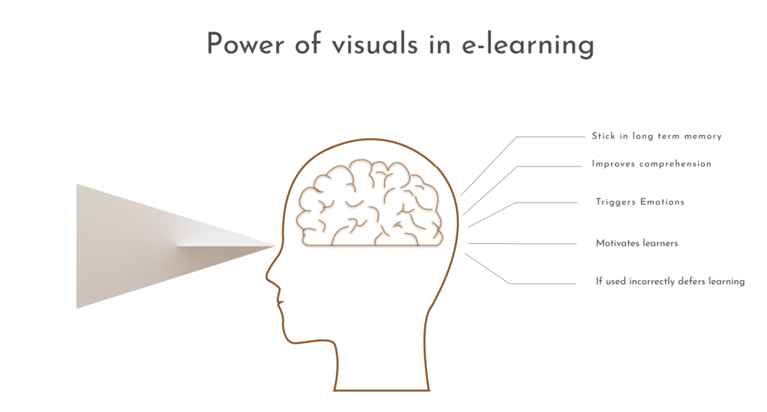

1. **External Interface Requirements**
   1. **User Interfaces**

For Pixel users, Google Lens is available right in the camera. Just point the camera at the object you want to find out more about, and tap the Google Lens icon at the bottom of the screen.

As of recently, Google Lens was only available to non-Pixel users through the Google Photos app. Users would have to take a photo, and then open the Google Photos app to use the Google Lens feature.

However, in December Aparna Chennapragada, the VP of Google Lens & AR at Google, Tweeted an announcement that Google Lens would be available on iOS through the Google app:

Using Google Lens became a lot easier for iOS and other non-Pixel users. When you open the Google app, the Lens icon now appears in the search bar next to the mic icon. Simply point the camera at the object you want to know more about, and the app will try to identify what it is.

* 1. **Hardware Interfaces**

There is, of course, the vacation beach pic, the kid’s winter recital, and the one--or ten--obligatory goofy selfie(s). But there’s also the book that caught my eye at a friend’s place, the screenshot of an insightful tweet and the tracking number on a package.

As our phones go everywhere with us, and storage becomes cheaper, we’re taking more photos of more types of things. We’re of course capturing sunsets and selfies, but people say 10 to 15 percent of the pictures being taken are of practical things like receipts and shopping lists.

To me, using our cameras to help us with our day-to-day activities makes sense at a fundamental human level. We are visual beings—by some estimates, 30 percent of the neurons in the cortex of our brain are for vision. Every waking moment, we rely on our vision to make sense of our surroundings, remember all sorts of information, and explore the world around us.

* 1. **Software Interfaces**

The way we use our cameras is not the only thing that’s changing: the tech behind our  cameras is evolving too. As hardware, software, and AI continue to advance, I believe the camera will go well beyond taking photos—it will help you search what you see, browse the world around you, and get things done.

That’s why we started Google Lens last year as a first step in this journey. Last week, we launched a redesigned Lens experience across Android and iOS, and [brought it to iOS users](https://twitter.com/Google/status/1072263705767936006)via the [Google app](https://itunes.apple.com/us/app/google/id284815942?mt=8).

I’ve spent the last decade leading teams that build products which use AI to help people in their daily lives, through Search, Assistant and now Google Lens. I see the camera opening up a whole new set of opportunities for information discovery and assistance. Here are just a few that we’re addressing with Lens.

* 1. **Communications Interfaces**

**What is Google Lens**? **Google Lens** is a super-powered version of **Google** Googles, and it's quite similar to Samsung's Bixby Vision. It enables you to do things such as point your phone at something, such as a specific flower, and then ask **Google** Assistant what the object you're pointing at is.

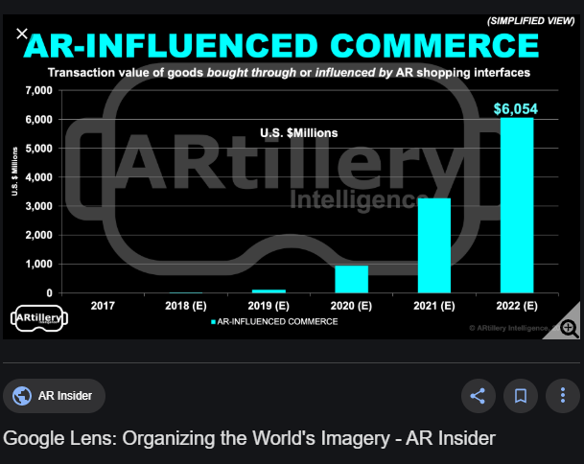

1. **Other Nonfunctional Requirements**
   1. **Performance Requirements**

**Google** had only revealed the manufacturers of those additional 10 **devices**: LG, Motorola, Xiaomi, Sony Mobile, HMD / Nokia, Transsion, TCL, OnePlus, BQ, and Asus. For the Android **devices** that aren't on the list, the **Lens** app might serve to patch up any holes in coverage.

* 1. **Safety Requirements**

It’s important to note that at this time Google Lens is not being rolled out to all devices at the same time. Instead, Google has opted to release the function to certain phones in batches. It appears as though Google is targeting flagship devices first; however, the goal is to add Google Lens to all devices at some point. If you have updated Google Photos and find that you don’t have access to Google Lens, it means that it hasn’t been released to your device yet. The only thing you can do is be patient and keep your eyes peeled for updates!

* 1. **Security Requirements**

The real “revolution” of **Google Lens** is not technological, it is social. Because **Google** is putting an “eye” on each Android phone, and each user is becoming a rich media information supplier for **Google**. When a user is scanning those restaurants described by Sundar, it is not only scanning those restaurants but also the people inside them and what is happening next.

* 1. **Software Quality Attributes**
     1. **Learn About Brands**

Imagine you’re walking through a parking lot, and you spot your dream car. It’s everything you ever wanted in a vehicle, and you need to get one.

With Google Lens, you can take a snapshot of that vehicle and tap the Lens icon to research the internet for the nearest dealership that carries it.

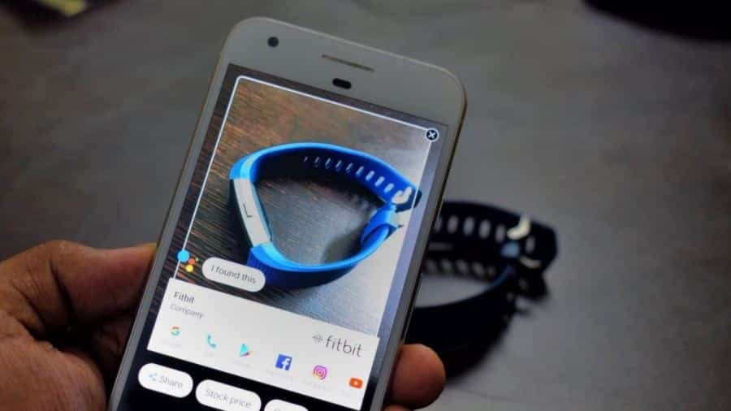

* + 1. **Find Similar Products**

In addition to identifying the brand of objects so you can buy them, Google Lens can also find related items to objects or text in the photo.

For example, if you run Google Lens on a picture with a quote, it’ll provide you with related products you can buy featuring that quote on them.

* + 1. **Identify Unknown Objects**

One of the most useful tasks Google Lens can do, especially when you’re traveling, is helping you identify plants, buildings, and more that you’ve never seen before.

You might be walking through a city gardens and spot an unusual plant that you want to identify. Google Lens can help. It’ll use Google to identify the most likely plant species that match the one in your photo.

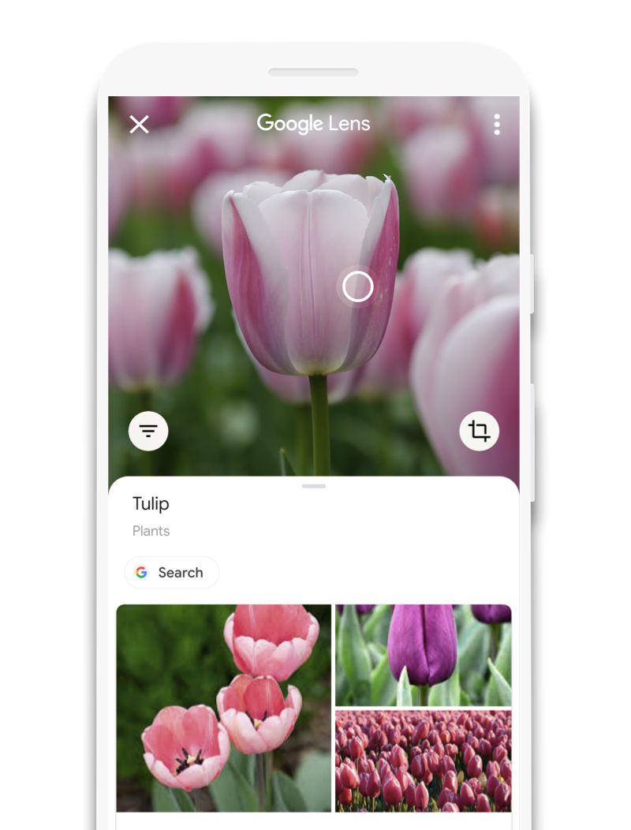

* + 1. **Capture Document Information**

The coolest feature of Google Lens is text recognition. You can take a picture of any document, and the app will recognize any text in the photo and covert it to actual text inside the app.

* + 1. **Get Contact Info From Business Cards**

Google Lens can work its magic on any photo you’ve captured that includes an address or a phone number. Usually this would be a business card, but it works with any other document too.

# Find a look you like

See an outfit that caught your eye? Or a chair that's perfect for your living room? Get inspired by similar clothes, furniture, and home decor—without having to describe what you're looking for in a search box.

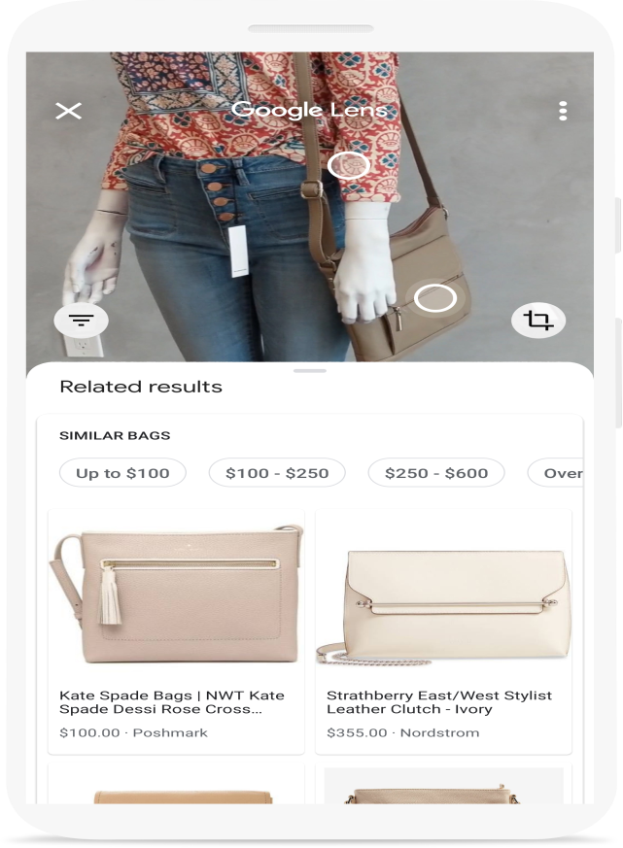

1. **Other Requirements**

<Define any other requirements not covered elsewhere in the SRS. This might include database requirements, internationalization requirements, legal requirements, reuse objectives for the project, and so on. Add any new sections that are pertinent to the project.>

**Appendix A: Glossary**

I/O-Input-Output

AI-Artificial Intelligence

QR-Quick Response